POLYTECHNIC OF TURIN

# Bioengineering of exercise and sport

Final Report

# Estimation of energy expenditure using acceleration data recorded with smart device during running



**Group Components**

Elena De Santis 289731 Laura Mazzoletti 292229

Francesco Richetto 292281

Benedetta Sabbadini 292182

Luca Scorrano 296047

Academic Year 2021-2022

# Experimental protocol

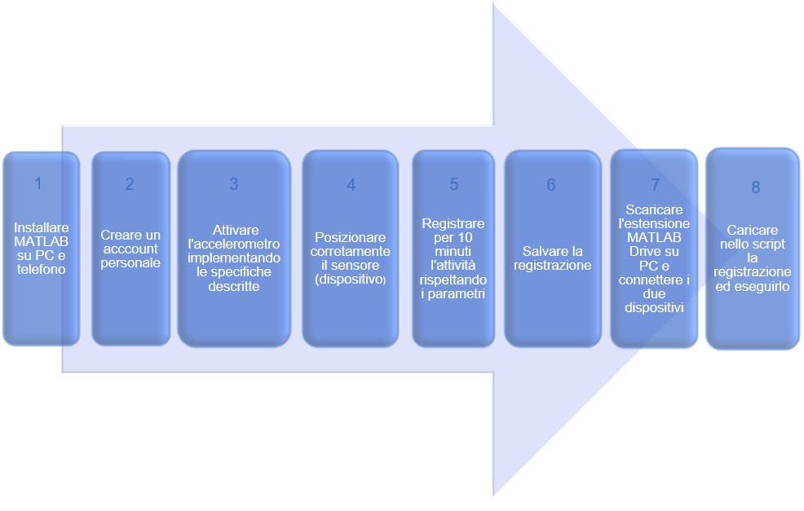

Figure 3: Outline of experimental protocol

Install MATLAB on the computer and the MATLAB Mobile version on the phone, create a personal account and access it from both devices.

Open the app on the phone and click on the 'Sensors' item in the menu. Activate the triaxial acceleration sensor ("Accelerations") and set its parameters as described in section 2.

When the subject is ready, press 'START': the recording should remain active for a continuous duration of at least 10 minutes and the phone should be placed on the longitudinal axis at the area of the body between the lower edge of the thorax, above, and the upper edge of the pelvis, below. The Y-axis of the sensor should be parallel to the subject's longitudinal axis in the inferior-superior direction and the Z-axis in the posterior-anterior direction.

An activity of moderate intensity is to be recorded: the subject is to run trying to maintain an average speed of between 8 and 10 km/h. The running should be performed on asphalted ground with a gradient of no more than 30 % at an altitude of less than 30 m above sea level.

Once the recording is finished, save it in 'Sensor logs' with the name 'Acc_run.mat'.

Now download the "MATLAB Drive" extension to your computer and connect the two devices. Access MATLAB from the computer, open the "MATLAB Drive" folder and click on the registration, which will be located in the "MobileSensorData" folder. Subsequently, open the MATLAB code 'Dis- pendio_energetico.mat' and click on Run: the calculated energy expenditure value will be returned automatically displayed in the form of a graph (see Fig.2).

1

# Instrumentation

The MATLAB mobile smartphone application, version 5.8.0 installed on the Honor 10 Lite, model COL-L29, version Android 10, is used for the recording of acceleration data. The in- stalled app makes use of the device's triaxial accelerometer, with a sampling rate set at 50 Hz.

The Huawei Watch GT 2-98F smartwatch, version 1.0.11.38, was used for the energy expenditure calculation comparison. Data processing is carried out on MATLAB software, version R2021b.

# Data Analysis

The collected data were processed using the algorithm proposed by Bouten et al. [1] where, from acceleration data filtered with a Chebyshev type 1 bandpass filter (1-20 Hz), the energy expenditure is estimated.

The method provides that from the integral of the absolute acceleration *IAA_tot*, implementing it in the dis- crete as in formula (1) and (2), the power relative to the mass of the subject *EE_act* is obtained.

N-1

∑ *|*

*IAAx*

= *∆t* ( *a*

2 *x*

n=1

[*n*]*|* + *|ax*

[*n* + 1]*|* (1)

*IAAtot* = *IAAx* + IAA*y* + *IAAz*  (2)

Since *∆t* must be constant in order to use formula (1), a resampling of the acceleration signals is carried out by means of linear interpolation.

The *EE* value*act* is converted into energy expended during the activity, taking into account the mass of the subject and the duration of the activity.

*EEact* = *α* + *βIAAtot*  (3)

Where *α* = 0*.*104 and *β* = 0*.*023.

For each period (*Tk* = *30s*), the power value obtained is converted into energy expenditure (kcal) (4) and added to the expenditure of the previous period:

*EE* = *EEact *Tk *bodymass*

4184

(4)

# Result

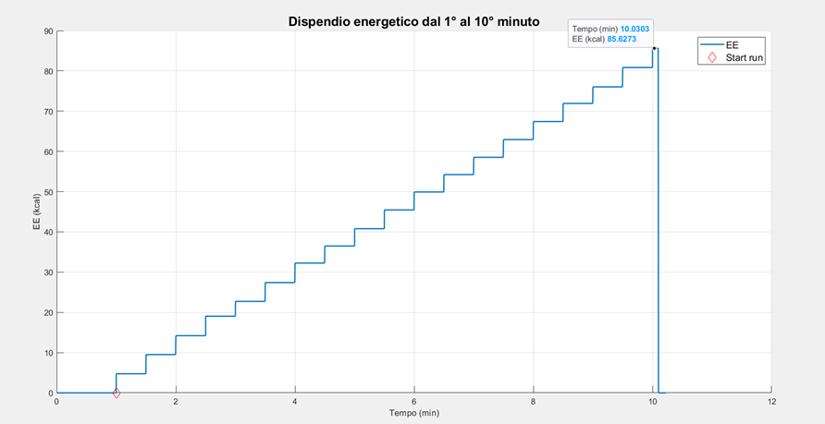

Figure 2: Energy Expenditure Graph

# Conclusions

Processing the acceleration data recorded in the test we performed and applying the algorithm pro- posed by Bouten et al. [BCV94] results in an energy expenditure of 85.63 kcal (see

Fig.2). By comparing the result with the values calculated by smartwatch, we can confirm the reliability of the method we used.

In fact, as shown in Fig. 1, it can be seen that the calculation of energy expenditure by the wearable device (83 kcal) is in line with the result we estimated. We can assume that the results we obtained are more than satisfactory.

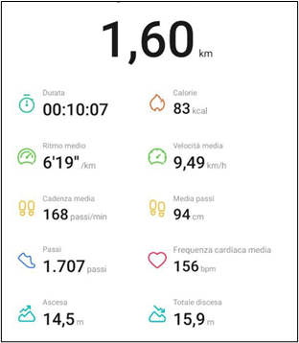

Figure 1: Parameters obtained from Huawei Watch GT 2-98F smartwatch device

# References

[BCV94] Verduin M. Janssen J. D. Bouten C. V., Westerterp K. R. Assessment of energy expenditure for physical activity using a triaxial accelerometer. 1994.